Traditions & Holidays:

Śmigus-dyngus (Wet Monday) is a holiday celebrated every

year on Easter Monday as a way to symbolize life and a plentiful harvest. It usually involves people, specifically boys, throwing huge amounts of water on girls as a way to show affection, including in some areas throwing them into rivers. However, the girls could avoid this fate by giving out painted Easter eggs called pisanki that symbolize a good harvest, successful relationships, and healthy childbirth. Furthermore, they are given the chance on Tuesday to do the same to the boys. Now, many people (including Polish Americans) use it as a way to celebrate and have fun with friends and family.

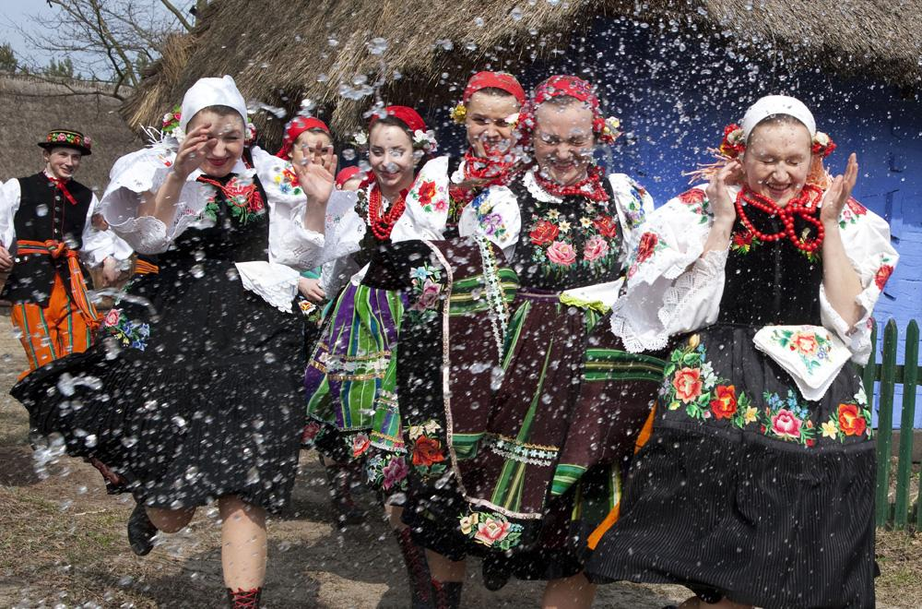

The Oplatek (Christmas Wafer) is a Polish Catholic tradition celebrated every

year on Christmas Eve. They are decorated with pictures depicting various biblical, Christmas-related scenes. The wafer has pieces broken off of it and eaten as it is passed around the table by family members while a prayer is recited. This is done to symbolize unity within both the family and the church.

